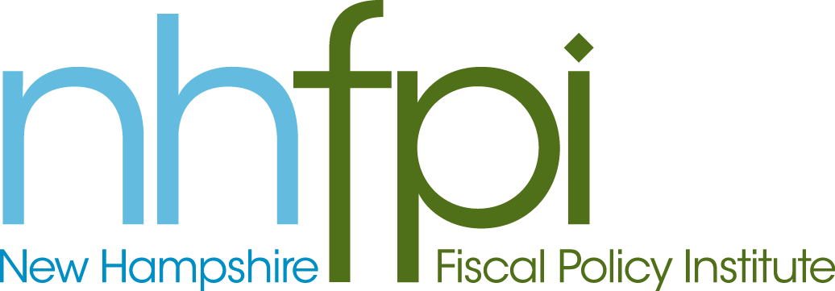
news release

FOR IMMEDIATE RELEASE July 23, 2013
CONTACT Anne Saunders
603.856.8337 x2

Accepting Federal Funds to Expand Medicaid Would
Save the State Money and Cover More Families

CONCORD – Members of the Medicaid Expansion Study Commission began discussions today about accepting federal funds to cover more New Hampshire families with health insurance via Medicaid.

While the state would face some up-front costs, it would benefit from new revenue and savings elsewhere in the budget. Taking advantage of just two major offsets could result in no net cost to New Hampshire through the end of the decade, according to New Hampshire Fiscal Policy Institute Executive Director Jeff McLynch.

“Accepting federal funds to cover more people through Medicaid makes sense. We benefit from a healthier and more productive workforce at little cost, and potentially real savings, to the state,” McLynch said.

In particular, New Hampshire’s decision to implement a managed care program for Medicaid means that extending Medicaid coverage to more people would generate additional insurance premium tax revenue because private managed care companies are subject to the tax. The additional revenue over the FY 2014-2020 period would add up to almost $40 million, according to the state Department of Health and Human Services.

In addition, the department estimated that expanding the state’s Medicaid program would reduce expenditures in the Department of Corrections by roughly $5 million total through FY 2020.

Hospitals also would benefit. Over the FY 2014-2015 biennium alone, they would save more than $50 million on uncompensated care costs if Medicaid is extended to more low-income adults, the department concluded.

The nine-member commission, which includes House, Senate and public members, is tasked with studying the potential costs and benefits of accepting federal funds to extend Medicaid eligibility to more low-income adults. The federal government would pay 100 percent of the benefit costs from 2014 through 2016 and gradually scale back to 90 percent in 2020. The commission is due to report its findings by Oct. 15.
-30-

