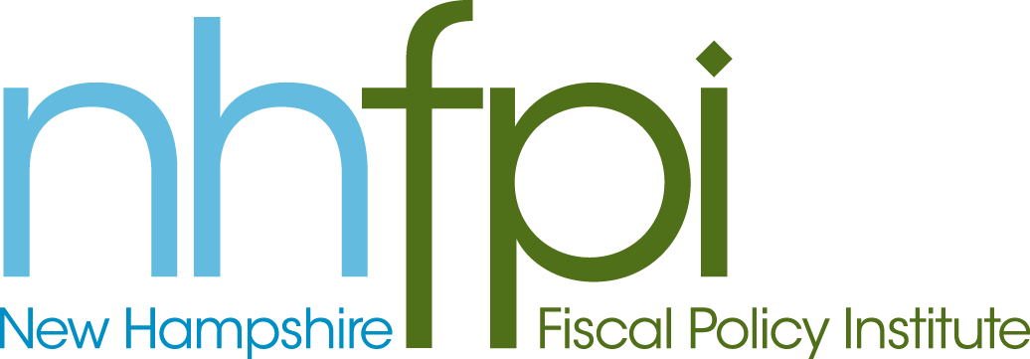
news release

FOR IMMEDIATE RELEASE June 20, 2013
CONTACT Anne Saunders
603.856.8337 x2

House-Senate Agreement on Medicaid Expansion
Moves the Issue in the Right Direction

CONCORD – The agreement reached today between budget negotiators in the House and Senate makes progress towards the goal of accepting federal funds to get more New Hampshire families covered with health insurance, according to New Hampshire Fiscal Policy Institute Executive Director Jeff McLynch.

“We are glad to see this step in the right direction but disappointed that the House and Senate negotiators did not set a date certain to act on accepting federal funds to extend Medicaid. Thousands of New Hampshire families are still waiting and they need the security of knowing they will have access to affordable health care when they need it,” he said.

“We ask the study commission to meet promptly and move quickly to clear a path so the state can maximize the benefit from the 100 percent federal funding for Medicaid expansion that is available only through 2016,” he added.

-30-

