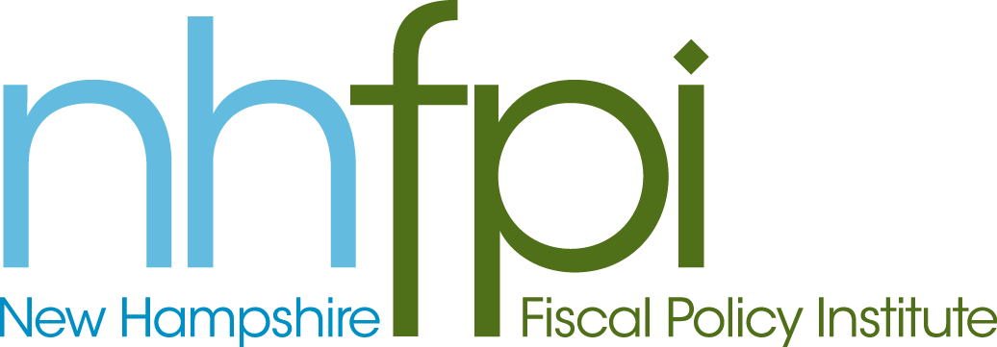
news release

FOR IMMEDIATE RELEASE January 9, 2013
CONTACT Anne Saunders
603.856.8337 x2

NHFPI Staff Brief Lawmakers on Medicaid Managed Care,
Tax and Budget Issues

CONCORD – New Hampshire Fiscal Policy Institute Executive Director Jeff McLynch and Policy Analyst Deborah Fournier spoke to lawmakers today as part of House efforts to gather information heading into the 2013 legislative session.

McLynch was invited to speak to the House Ways and Means Committee about tax and budget issues that will affect the development of the 2014-2015 biennial budget.

Among other things, he highlighted the impact that changes in tax policy will have on the upcoming budget.

“Tax cuts adopted in the last legislature will drain more than $60 million out of the state’s next budget. Unless they are suspended or repealed, they will severely constrain New Hampshire’s ability to invest in its future and protect vulnerable residents,” he said.

Fournier was invited to speak to the House Health, Human Services and Elderly Affairs Committee this morning regarding the ongoing effort to implement a managed care system for Medicaid recipients.

“Lawmakers know this will be an issue that affects many of their constituents,” she said.

-30-

