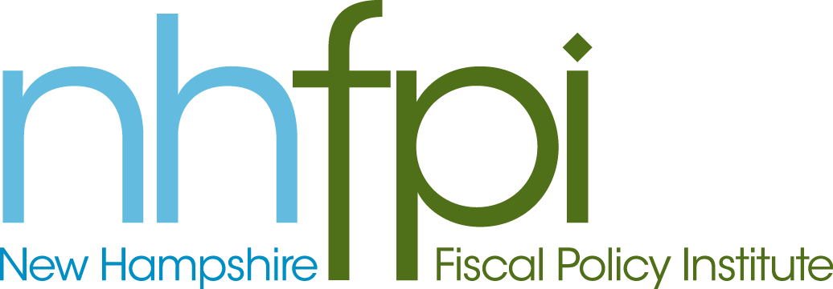
news release

FOR IMMEDIATE RELEASE January 31, 2014
CONTACT AnnMarie French
603.856.8337 x2

NHFPI’s ‘Government in the Granite State’ Conference Explores the Role of Government in Solving Critical Public Policy Issues

CONCORD – The New Hampshire Fiscal Policy Institute (NHFPI) today gathered national experts and New Hampshire government and nonprofit leaders for an in depth exploration of the role of government in the Granite State. Held at the Grappone Center in Concord, NHFPI’s “Government in the Granite State: Past, Present and Future” conference focused on the strategies New Hampshire uses to foster economic security, promote health, support education, and address other critical public priorities.

“We hope that today’s dialogues and exchanges mark the renewal of a sustained conversation – a conversation that includes voices from across our state -- about the ways in which public policies can advance wider opportunity and shared prosperity in the Granite State,” said NHFPI Executive Director Jeff McLynch.

NHFPI’s first annual policy conference, “Government in the Granite State” featured four panel presentations and discussions led by national topic experts and local leaders. The more than 125 conference participants engaged in insightful dialogue around the challenges and opportunities for addressing public policy concerns in the state. Attendees included more than a dozen members of the New Hampshire Legislature, many of whom voiced concern for the state's fiscal future.

In his keynote address, Michael Leachman, Director of State Fiscal Research for the Center on Budget and Policy Priorities, provided analysis of challenges facing states today, including national and regional trends and key findings for New Hampshire.

“Child poverty costs the country about $500 billion per year in foregone economic growth,” said Leachman. “Kids who grow up in poverty are less healthy and less productive workers as adults. By investing upfront in those kids, and helping their families move up the economic ladder, states can save a lot of money in the long run.”

National speakers in addition to Leachman included Tricia Brooks, Senior Fellow, Georgetown University Health Policy Institute; Tom Harnisch, Assistant Director of State Relations and Policy Analysis, American Association of State Colleges and Universities; and Doug Hall, Director, Economic Analysis and Research Network.

New Hampshire presenters included: Tom Raffio, President and CEO, Northeast Delta Dental; Beth Mattingly, Director of Research on Vulnerable Families, The Carsey Institute at the University of New Hampshire; Jeanne Ryer, Director, NH Citizens Health Initiative; Lisa Kaplan Howe, Policy Director, NH Voices for Health; Mark Joyce, Executive Director, NH School Administrators Association; Rebecca Harris, Director, Transport NH; Judy Silva, Executive Director, NH Municipal Association; Bob Mack, President, NH Local Welfare Administrators Association; and Ben Frost, Director of Public Affairs, NH Housing.

The New Hampshire Fiscal Policy Institute (NHFPI) is an independent, non-partisan organization dedicated to exploring, developing, and promoting public policies that foster economic opportunity and prosperity for all New Hampshire residents, with an emphasis on low- and moderate-income families and individuals. Learn more at www.nhfpi.org.

-30-

