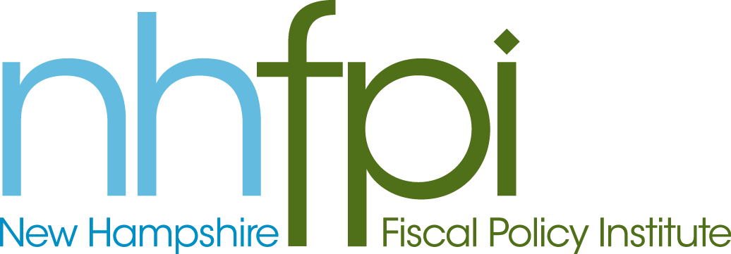
news release

FOR IMMEDIATE RELEASE February 6, 2014
CONTACT AnnMarie French
603.856.8337 x2

NHFPI Statement on Governor’s Support for Minimum Wage Increase

CONCORD – In her State of the State address earlier today, Governor Maggie Hassan called for an increase in New Hampshire’s minimum wage, currently the lowest in New England at $7.25 per hour.

“Governor Hassan should be commended for her support for a higher minimum wage,” said NHFPI Executive Director Jeff McLynch. “New Hampshire’s workers deserve a fair day’s pay for a fair day’s work. Yet far too many are still struggling just to get by. Increasing the minimum wage will put New Hampshire on a better path toward a more prosperous economy and greater opportunities for Granite Staters.”

Legislation (HB 1403) now before the House of Representatives would raise New Hampshire’s minimum wage in two stages and provide for annual cost of living increases in the future. It would increase the minimum to $8.25 per hour on January 1, 2015 and to $9.00 per hour on January 1, 2016. Beginning January 1, 2017, it would automatically increase New Hampshire’s minimum wage to account for inflation (based on the Consumer Price Index).

“Raising New Hampshire’s minimum wage would, on average, put $870 per year in the pockets of hard working but low earning Granite Staters,” said McLynch. “Those higher wages will almost immediately be used to buy food at local supermarkets, clothes at local shops, and gas at local convenience stores, improving sales at businesses across the state.”

An analysis conducted by the Economic Policy Institute indicates that HB 1403 would either directly or indirectly increase the wages of 76,000 Granite Staters. Of those who would be affected, 72 percent are adults age 20 and older; 32 percent work full-time; 59 percent are women; and 14 percent are parents.

New Hampshire voters broadly support an increase to the minimum wage. Public Policy Polling results released January 15, 2014, show New Hampshire voters support increasing the minimum wage to $10 an hour by a margin of 60% support to 29% opposed.

The New Hampshire Fiscal Policy Institute (NHFPI) is an independent, non-partisan organization dedicated to exploring, developing, and promoting public policies that foster economic opportunity and prosperity for all New Hampshire residents, with an emphasis on low- and moderate-income families and individuals. Learn more at www.nhfpi.org.

-30-

